Township and Rural Education in
South Africa July 19 – August 8, 2017
This course introduces all students to primary and secondary education in the township and rural schools of Grahamstown, South Africa. The program aims to have students analyze personal cross-cultural competence and understanding to effectively teach learners from diverse backgrounds. While designed for education majors, this internship is open to other students as well. Non-majors will be paired with education majors for all classroom experiences. Participants will complete a course (in Spring 2017) that focuses on the history of South Africa, culture and customs unique to the Eastern Cape region, and rural education in South Africa; design and implement lesson plans focused on basic reading and English concepts for South African learners, grades 5-8; complete an intensive field placement in a township and rural school, teaching 20 hours per week; and attend weekly lectures on Xhosa culture and languages specific to the Eastern Cape region at Rhodes University.
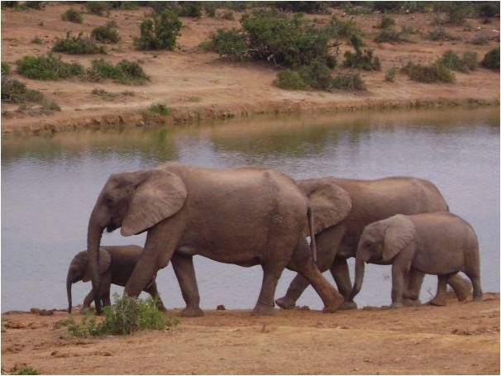

Eligibility, Prerequisites, and Academic Credit
Applicants should have sophomore standing and a
minimum cumulative GPA of 3.0. Pre-requisites
include ED 101 or ED 103, and SPE 100 or ED 207, or
permission of the program director. Applicants must
speak with Professors La Jerne Cornish and Rick Southerland before applying.

For application information, please contact:
The Office of International Studies
Goucher College – Dorsey Center 207
Ph: 410.337.6455 Fax: 410.337.6443
Email: Intlstudies@goucher.edu
La Jerne Cornish: lcornish@goucher.edu
Rick Southerland: james.southerland@goucher.edu

Application and Study Abroad Deposit Deadlines
November 7, 2016: Application deadline
November 30, 2016: $500 non-refundable deposit due
February 17, 2017: Final payment due

Financial Aid

Loans are also available to eligible students through the Financial Aid Office in SAS. Students who qualify for the study abroad voucher are able to apply the voucher to the cost of this program. Students entering Goucher beginning in Fall 2014 may apply for a Goucher Global Grant in lieu of the study abroad voucher.

Passport and Visa Information
Students are required to have passports for all Goucher programs. Failure to have a passport will prohibit participation in the program. Please apply for a passport as soon as possible at:
http://travel.state.gov/passport/get/get_4855.html

Program Cost Breakdown

Total cost paid to Goucher | $5,200
This cost covers the following: | International airfare  Lodging  All Meals  Excursions  Transportation within host country  Seminars  Entrance fees  Insurance

Total cost paid to Goucher | $5,200
Total cost inclusive of airfare | $5,200*

Note: Information contained in this flier is accurate at the time of publication, but is based on conditions over which Goucher has no control, including rates of exchange, airline fares, student enrollment, and the availability of facilities. Therefore, this information is subject to change without notice.

*Please note: Students will need to budget for personal expenses, meals not covered by program, and passport if needed.

